Expense Report for reimbursement of costs
✓ Payment to be reimbursed via transfer
Payment to be reimbursed in cash

Total Amount (in EUR) | EUR 236.78
Reimbursement over the sum of (in EUR) | EUR
Type of costs | Travel reimbursement
FULL Name (Capital letters) | NASSOS STYLIANOU
Activity for which the costs occurred
Number of individual tickets (the scans or email confirmations of the tickets should be sent to the Office, or separately glued to a A4 sheets of paper and handed in) attached to this report and listed below in the table):
Use this converter to convert local currency into EUR (make sure to use the date of the invoice):
http://ec.europa.eu/budget/contracts_grants/info_contracts/inforeuro/inforeuro_en.cfm

Date of invoice/ticket | Type of expense | Local currency | EUR
02/09/2017 | Return plane ticket to Berlin for CAT | / | 236.78 EUR
If necessary, add more rows
 |  |  | Sum EUR: 236.78

Please carefully read all the options and choose the one that applies for you. In order to make transfer outside of the Eurozone, we need additional information. Please make sure to future all of them.

Option 1: EURO Account details:
Name of the account holder
IBAN (bank account)
SWIFT / BIC code

Option 2: If you do not have a EURO account, your account details:
Currency of the account | POUND STERLING
Name of the account holder | NASSOS STYLIANOU
Address (Street Number, Postal Code, City, Country) | FLAT 23, EXCHANGE BUILDING, 132 COMMERCIAL STREET, E1 6NG, LONDON, UK
Mail address | stylianou.nassos@gmail.com
Recipient Phone Number | +44 7515029511
Last 4 digits of recipient’s card number | N/A
IBAN (bank account) | GB48ABBY09012885953027
SWIFT / BIC code | ABBYGB2LXXX

I hereby claim reimbursement of the costs listed above, and I state that I have completed all information contained herein accurately and to the best of my knowledge. Moreover, I state that I have not claimed reimbursement for these costs from any third party, and will not do so in the future.
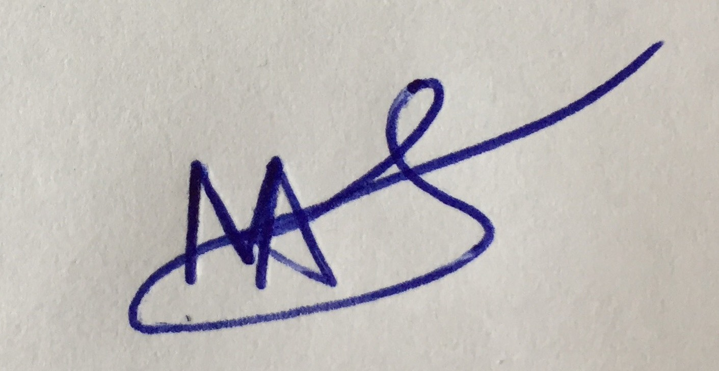
03/09/2017, London, UK ___________________________________
Date, Place Signature

To be completed by EYP/SF:
Approved by | Anya Suprunenko
Approved by | Lukas Fendel
Cost centre I Type of cost | KS: 4.30.02 KA: 2210
Date of reimbursement

